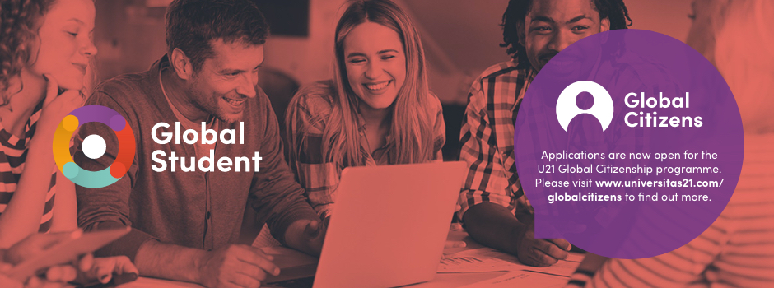

U21 is offering an online, international opportunity for students around the world this October. Universitas 21 Global Citizens is an online leadership development programme, delivered by Common Purpose, a global not-for-profit organisation that specializes in Cross-Boundary Leadership. Participants will develop ideas together, across borders and time zones, honing skills needed to thrive in the 21st century whilst tackling some of the world’s most pressing problems, outlined in Sustainable Development goals Hear from previous participants on our website.

The course is open to 2,000 students across the U21 global network of 27 universities, spanning 18 countries and 19 time zones. Throughout the programme participants will engage with and learn from students across the globe.

The three-week programme launches on Monday 4 October. Each week requires a minimum of 3 hours of online learning that you can complete in your own time. In addition during weeks 1 and 2 there are real-time, online reflection workshops, where you will draw on the learning from that week and engage in discussions with other students from across the globe.

Successful completion of the programme and all activities will earn you the Global Citizens micro-credential which you can display on your LinkedIn profile, demonstrating that you have developed the skills to tackle complex global issues and stand up as a leader.

As a result of the programme, you will be:

- Equipped to take rapid action on the Sustainable Development Goal that you choose
- Able to step outwards and collaborate with diverse networks
- Ready to challenge preconceptions and better inform other people’s perspectives
- Better equipped to operate across hierarchies
- Better prepared to live and maintain your values and integrity
- Better connected to U21 students around the world

Find out more about the U21 Global Citizens Programme
We hope that you will want to join up for this free programme. Please note that there is a limited number of spaces per member university and U21 will operate a waiting list once all allocated spaces are filled. Applications close on the 24 September, 5pm (GMT).

Apply now

