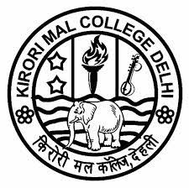
KIRORI MAL COLLEGE

UNIVERSITY OF DELHI, DELHI 110007
KIRORI MAL COLLEGE ALUMNI NETWORK

NOTICE

KMC ALMA CONNECT 2021

DATE: 26-092021

Kirori Mal College (KMC) Alumni Network is delighted to share with all of you that our two alumni namely Mr. Yash Jaluka from B.A (Eco)-Honours, Class of 2017 and Mr. Sachin Agarwal from B.A. History (Hons), Class of 2020 have secured All India Rank 4th and 610th respectively in the Civil Services Examination 2020 held by the Union Public Service Commission in January 2021.

Heartiest Congratulations to both Mr. Yash Jaluka & Mr. Sachin Agarwal for making KMC and the University of Delhi proud. Keep shining and keep moving forward!

(Professor Vibha Singh Chauhan) (Professor Seema Joshi)
Principal Staff Coordinator
Kirori Mal College Kirori Mal College Alumni Network

